Register Number

SRM Institute of Science and Technology
Set - B
College of Engineering and Technology
School of Computing
SRM Nagar, Kattankulathur – 603203, Chengalpattu District, Tamil Nadu

Academic Year: 2025-26 (EVEN SEM)
Test: FT- IV Date:
Course Code & Title: Duration: 100 Minutes
Year & Sem: III Year / VI Sem Max. Marks: 50

Part – B
(5 x 5 = 25 Marks)
Instructions: Answer ANY 5 questions
Q.  No | Questions | Marks | BL | CO | PO | PI Code
11 | Illustrate the common problems faced when handling large datasets by providing suitable examples or scenarios.  a) Identify common challenges encountered in handling large datasets. (2 Marks)  - Memory limitations – Data may not fit into RAM.  - Slow processing time – Operations become computationally expensive.  - Data quality issues – Missing values, noise, and inconsistencies increase with size.  - Scalability issues – Traditional tools may fail with growing data volume.  - Data integration complexity – Combining multiple large sources is difficult.  b) Demonstrate any two problems with examples. (2 Marks)  1. Memory limitation problem  - Example: A dataset with 10 million rows is loaded using Pandas. The system crashes due to insufficient RAM.  2. Slow processing problem  - Example: Performing sorting or grouping on a large dataset (e.g., customer transactions of an e-commerce site) takes several minutes or hours.  c) Apply appropriate techniques or tools to address these problems. (1 Mark)  - Use chunk processing (pandas.read_csv(chunksize=...)) to handle large files.  - Use big data frameworks like Apache Spark or Hadoop for distributed processing.  - Apply data cleaning and preprocessing techniques to improve quality. | 5 | 3 | 3 | 5 | 5.2.1
12 | A healthcare dataset contains missing values in two columns: 15% in “Blood Pressure” and 2% in “Age”. Apply appropriate techniques to handle these missing values.  - Identify suitable methods to handle missing values in both columns. (2 Marks)  - Apply appropriate techniques to treat the missing values in “Blood Pressure” and “Age”. (2 Marks)  import pandas as pd  import numpy as np  # Create dataset  df = pd.DataFrame({'Patient': ['P1', 'P2', 'P3', 'P4', 'P5'],  'Blood Pressure': [120, np.nan, 140, 130, np.nan],  'Age': [25, 30, np.nan, 28, 32]  })  print("Original Dataset:\n")  print(df)  # Handle missing values  # a) Blood Pressure → Median Imputation  bp_median = df['Blood Pressure'].median()  df['Blood Pressure'].fillna(bp_median, inplace=True)  # b. Age → Mean Imputation  age_mean = df['Age'].mean()  df['Age'].fillna(age_mean, inplace=True)  print("\nUpdated Dataset after Handling Missing Values:\n")  print(df)  - Present the updated dataset after handling missing values. (1 Mark)  Patient Blood Pressure Age  P1 120 25.00  P2 130 30.00  P3 140 28.75  P4 130 28.00  P5 130 32.00 | 5 | 3 | 3 | 5 | 5.2.2
13 | An e-commerce company maintains two datasets:  - Customers: CustomerID, Name  - Orders: CustomerID, OrderAmount  Some customers have not placed any orders. Apply an appropriate merging technique to combine these datasets.  a) Identify and apply a suitable merge (join) operation to combine the datasets. (2 Marks)  Use a LEFT JOIN.  - This ensures all customers are included, even if they have not placed any orders.  - Missing orders will appear as NaN.  b) Perform the merge operation on sample data. (2 Marks)  import pandas as pd  customers = pd.DataFrame({'CustomerID': [1, 2, 3, 4],'Name': ['Alice', 'Bob', 'Charlie', 'David']})  orders = pd.DataFrame({'CustomerID': [1, 2, 2],'OrderAmount': [250, 150, 300]})  merged_df = pd.merge(customers, orders, on='CustomerID', how='left')  print(merged_df)  c) Display the resulting dataset after merging. (1 Mark)  CustomerID Name OrderAmount  1 Alice 250  2 Bob 150  2 Bob 300  3 Charlie NaN  4 David NaN | 5 | 3 | 3 | 5 | 5.2.2
14 | A data analyst is provided with a dataset containing the ages of patients and needs to examine the distribution and skewness of the data to gain meaningful insights.  a) Evaluate different Seaborn plots and select the most appropriate one for analyzing distribution and skewness. (1 Mark)  The most appropriate plot is a histogram with KDE (Kernel Density Estimate) using sns.histplot() or sns.displot(). It shows distribution, central tendency, and skewness clearly.  b) Implement the chosen visualization using Python code. (2 Marks)  import seaborn as sns  import matplotlib.pyplot as plt  import pandas as pd  df = pd.DataFrame({  'Age': [22, 25, 27, 30, 32, 35, 40, 45, 50, 60, 75]})  sns.histplot(df['Age'], kde=True)  plt.title("Age Distribution of Patients")  plt.xlabel("Age")  plt.ylabel("Frequency")  plt.show()  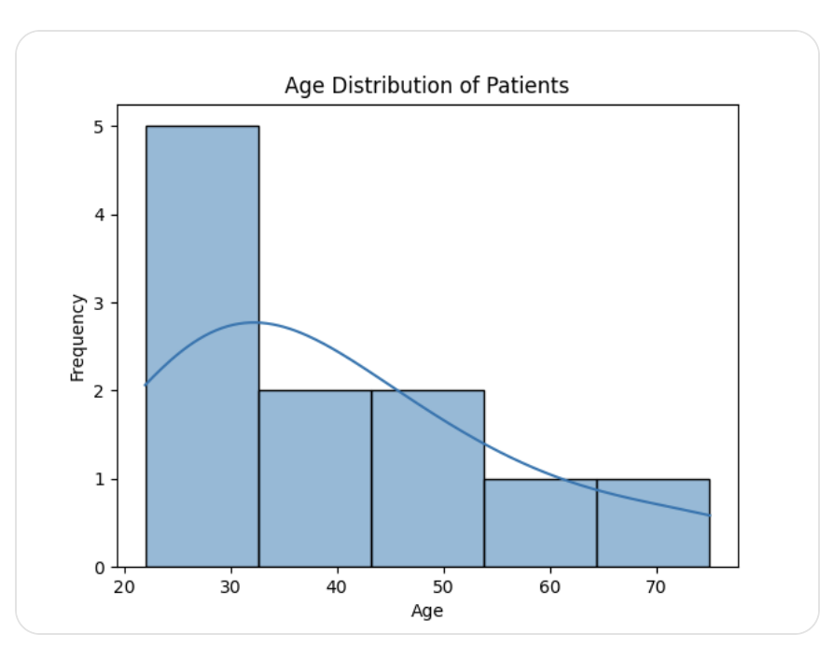  c) Analyze the resulting plot to identify patterns such as distribution shape, central tendency, and skewness. (1 Mark)  - Distribution shape: Slightly right-skewed (longer tail toward higher ages).  - Central tendency: Most values cluster around 30–45 years.  - Skewness: Presence of higher values (60, 75) pulls the distribution to the right.  - Interpret the insights obtained and explain what they reveal about the dataset. (1 Mark)  - The dataset mainly consists of middle-aged patients.  - A few elderly patients create positive skewness.  - This indicates that while most patients are in a moderate age range, there are outliers or fewer high-age cases, which may be important for healthcare planning. | 5 | 4 | 4 | 5 | 5.2.3
15 | A researcher wants to visualize temperature and humidity data in separate subplots within the same figure for better comparison and clarity.  a)Create a dataset for temperature and humidity. (1 Mark)  import pandas as pd  data = pd.DataFrame({'Day': [1, 2, 3, 4, 5],  'Temperature': [30, 32, 31, 29, 33],  'Humidity': [60, 65, 63, 70, 68]})  b) Illustrate how to create multiple subplots within a single figure. (2 Marks)  import matplotlib.pyplot as plt  fig, axes = plt.subplots(1, 2, figsize=(10, 4))  c) Label each subplot appropriately with titles and axis labels. (1 Mark)  # Temperature subplot  axes[0].plot(data['Day'], data['Temperature'])  axes[0].set_title("Temperature Variation")  axes[0].set_xlabel("Day")  axes[0].set_ylabel("Temperature (°C)")  # Humidity subplot  axes[1].plot(data['Day'], data['Humidity'])  axes[1].set_title("Humidity Variation")  axes[1].set_xlabel("Day")  axes[1].set_ylabel("Humidity (%)")  d) Display the final output with both plots. (1 Mark)  plt.tight_layout()  plt.show() | 5 | 4 | 4 | 5 | 5.2.1
16 | A retail store visualizes monthly sales data using Month and Sales. The analyst needs to enhance the visualization for better clarity and presentation by evaluating and applying appropriate styling techniques.  a)Create a bar plot to represent Month vs Sales. (1 Mark)  import matplotlib.pyplot as plt  # Sample data  months = ['Jan', 'Feb', 'Mar', 'Apr', 'May']  sales = [200, 250, 300, 280, 350]  # Bar plot  plt.bar(months, sales)  plt.xlabel("Month")  plt.ylabel("Sales")  plt.show()  b) Apply a suitable Matplotlib style and examine its effect on the visualization. (1 Mark)  plt.style.use('ggplot') # Apply style  plt.bar(months, sales)  plt.xlabel("Month")  plt.ylabel("Sales")  plt.show()  c) Analyze how customizing bar colors influences readability and visual appeal. (1 Mark)  plt.style.use('ggplot')  plt.bar(months, sales, color=['blue', 'orange', 'green', 'red', 'purple'])  plt.xlabel("Month")  plt.ylabel("Sales")  plt.show()  - Enhance the plot by adding gridlines and a title, and interpret how these elements improve the overall presentation. (2 Marks)  plt.bar(months, sales, color=['blue', 'orange', 'green', 'red', 'purple'])  plt.title("Monthly Sales Analysis")  plt.xlabel("Month")  plt.ylabel("Sales")  plt.grid(True)  plt.show() | 5 | 4 | 4 | 5 | 5.2.2
17 | Create two datasets and plot them using a line graph with appropriate axis labels and legend, then analyze how these elements improve clarity and compare the trends between the datasets.  Create datasets and plot line graph  import matplotlib.pyplot as plt  # Dataset 1 (e.g., Product A sales)  months = ['Jan', 'Feb', 'Mar', 'Apr', 'May']  sales_A = [100, 150, 200, 250, 300]  # Dataset 2 (e.g., Product B sales)  sales_B = [80, 120, 180, 220, 260]  # Plot line graph  plt.plot(months, sales_A, label='Product A')  plt.plot(months, sales_B, label='Product B')  # Axis labels  plt.xlabel("Month")  plt.ylabel("Sales")  # Title  plt.title("Sales Comparison of Product A and Product B")  # Legend  plt.legend()  plt.show()  How labels and legend improve clarity  - Axis labels clearly define what each axis represents (Month vs Sales).  - Legend distinguishes between the two datasets (Product A vs Product B).  - Title provides context, making the graph easy to understand at a glance.  Trend comparison analysis  - Both datasets show an increasing trend over time.  - Product A consistently has higher sales than Product B.  - The gap between the two products remains relatively stable, indicating similar growth patterns. | 5 | 4 | 4 | 5 | 5.2.2

Part – C
(1 x 15= 15 Marks)
Instructions: Answer ALL the questions
Q.  No | Questions | Marks | BL | CO | PO | PI  Code
18 | An e-commerce company collects sales data from multiple regional systems. The dataset has the following structure:  - Columns include: Order_ID, Customer_ID, Region, Jan_Sales, Feb_Sales, Mar_Sales, Apr_Sales  - Each row represents a customer with monthly sales stored in separate columns (wide format)  - Issues identified:  - Sales data is spread across multiple columns instead of rows  - Some months have missing sales values (NaN)  - Region names are inconsistent (e.g., "South", "south ", "SOUTH")  - Duplicate entries for the same Customer_ID and Order_ID  - Requirement: Generate a time-series analysis of monthly sales  Perform the following operations:  a) Convert the dataset from wide format to long format (5)  import pandas as pd  import numpy as np  # Sample dataset  df = pd.DataFrame({  'Order_ID': [1, 2, 2, 3],  'Customer_ID': [101, 102, 102, 103],  'Region': ['South', 'south ', 'SOUTH', 'North'],  'Jan_Sales': [200, 150, 150, np.nan],  'Feb_Sales': [220, np.nan, np.nan, 180],  'Mar_Sales': [250, 200, 200, 190],  'Apr_Sales': [300, 250, 250, 210]  })  # Convert to long format  df_long = pd.melt(df,  id_vars=['Order_ID', 'Customer_ID', 'Region'],  var_name='Month',  value_name='Sales')  print(df_long.head())  b) Handle missing values in sales (2)  df_long['Sales'].fillna(df_long['Sales'].median(), inplace=True)  c) Standardize categorical data (Region) (2)  df_long['Region'] = df_long['Region'].str.strip().str.upper()  d) Remove duplicates (2)  df_long = df_long.drop_duplicates(subset=['Order_ID', 'Customer_ID', 'Month'])  e) Prepare the dataset for time-series analysis (3)  # Convert Month column to proper datetime format  df_long['Month'] = df_long['Month'].str.replace('_Sales', '')  df_long['Month'] = pd.to_datetime(df_long['Month'], format='%b')  # Sort values  df_long = df_long.sort_values(by='Month')  print(df_long)  Sample output (1)  Order_ID Customer_ID Region Month Sales  1 101 SOUTH Jan 200  2 102 SOUTH Jan 150  3 103 NORTH Jan 210  ... ... ... ... ... | 15 | 4 | 5 | 5 | 5.2.4
(OR)
19 | A hospital is analyzing patient health records collected from different departments to identify risk patterns. The dataset contains the following columns:  - Patient_ID  - Age (years)  - BMI (Body Mass Index)  - Cholesterol (mg/dL)  - Blood_Pressure (mmHg)  - Exercise_Hours (per week)  Data characteristics and requirements:  - Age ranges from 18 to 80 years  - BMI values vary widely and need distribution analysis  - Cholesterol values include some critical high-risk readings above 240 mg/dL  - Blood pressure values range from normal to hypertensive levels  - The hospital wants a dashboard-style visualization with multiple plots  - Axes must be customized for better readability  - Ticks should be adjusted for meaningful intervals  - Legends and labels must be added for clarity  - Critical cholesterol values must be highlighted using annotations  - A Seaborn theme should be applied for improved styling  - The final visualization must be saved for reporting purposes  Perform the following operations:  a) Create a 2×2 subplot layout using Matplotlib (2)  b) Plot a histogram of BMI values (2)  c) Create a scatter plot between Age and Cholesterol (2)  d) Plot a line plot for Blood_Pressure vs Age (2)  e) Modify ticks to display meaningful intervals (2)  f) Add axis labels and legends where necessary (2)  g) Annotate the highest cholesterol value in the scatter plot (3)  import pandas as pd  import numpy as np  import matplotlib.pyplot as plt  import seaborn as sns  # Apply seaborn theme  sns.set_theme(style="whitegrid")  # Sample dataset  df = pd.DataFrame({  'Patient_ID': range(1, 11),  'Age': [25, 30, 45, 50, 35, 60, 40, 55, 28, 65],  'BMI': [22, 27, 31, 29, 26, 33, 28, 30, 24, 35],  'Cholesterol': [180, 220, 250, 260, 210, 270, 230, 240, 200, 280],  'Blood_Pressure': [120, 125, 140, 150, 130, 160, 135, 145, 118, 155],  'Exercise_Hours': [3, 2, 1, 1, 2, 0, 2, 1, 3, 0]  })  # a) Create 2x2 subplot layout  fig, axes = plt.subplots(2, 2, figsize=(12, 8))  # b) Histogram of BMI  axes[0, 0].hist(df['BMI'])  axes[0, 0].set_title("BMI Distribution")  axes[0, 0].set_xlabel("BMI")  axes[0, 0].set_ylabel("Frequency")  # c) Scatter plot (Age vs Cholesterol)  axes[0, 1].scatter(df['Age'], df['Cholesterol'], label="Cholesterol Levels")  axes[0, 1].set_title("Age vs Cholesterol")  axes[0, 1].set_xlabel("Age")  axes[0, 1].set_ylabel("Cholesterol")  axes[0, 1].legend()  # g) Annotate highest cholesterol  max_idx = df['Cholesterol'].idxmax()  max_age = df.loc[max_idx, 'Age']  max_chol = df.loc[max_idx, 'Cholesterol']  axes[0, 1].annotate(f"High: {max_chol}",  (max_age, max_chol),  xytext=(max_age+2, max_chol+5),  arrowprops=dict())  # d) Line plot (Blood Pressure vs Age)  axes[1, 0].plot(df['Age'], df['Blood_Pressure'], label="Blood Pressure")  axes[1, 0].set_title("Blood Pressure vs Age")  axes[1, 0].set_xlabel("Age")  axes[1, 0].set_ylabel("Blood Pressure")  axes[1, 0].legend()  # e) Modify ticks  axes[1, 0].set_xticks(range(20, 81, 10))  axes[1, 0].set_yticks(range(110, 181, 10))  axes[0, 1].set_xticks(range(20, 81, 10))  axes[0, 1].set_yticks(range(150, 301, 25))  # Display  plt.show() | 15 | 4 | 5 | 5 | 5.2.4

Course Outcome (CO) and Bloom’s level (BL) Coverage in Questions

